HAYWARD SUNDAY LEAGUE ROUND UP - SUNDAY 2nd SEPTEMBER 2018
Reigning DIVISION ONE champions East Christchurch SSC began their defence of the title with a 5-2 success against JP Morgan thanks to Sam Kennedy (pen), Mitch East, Alex Whitehouse, and a couple of goals from Greg O’Mallo. Nathan Evans scored both goals for the visitors. Marcus Cullen, Jamie Morgan, and Dominic Falco nabbed two each in Talbot Rangers’ 8-2 triumph over Wakanda with Sam Phillips and Mark Rourke also on target. Nasim Meddah and Flyn Weardon were the Wakanda marksmen.
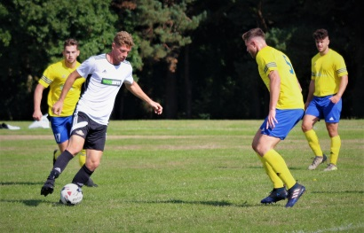
Levi Ridealgh and Dan Seymour netted for AFC Burton but Loch & Quay upended them 6-2 thanks to River Smith’s hat-trick and further goals from Rhys Jones, Pepe Smith, and James Keith. In the other Division One game, Dan Manuel scored both Abbey goals to give them the edge 2-1 against West Howe who replied through Adam Louka.
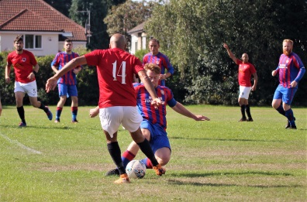
Liam Holland struck twice for Newtown Athletic, including one from the penalty spot, and Adam Janes weighed in with a towering far post header but Wiseguys had all the answers in DIVISION TWO, winning 7-3 thanks to Steve Flynn’s first half hat-trick and two apiece from Steve Haime and Fernando da Silva. Alderney Manor were 3-0 winners against Bournemouth Sports Mercury through John Smart, Mark Seal, and Stu MacFarlan while AFC Wimborne shaded it 3-2 against NMO courtesy of Alex Henley and a couple of goals from Matthew Groves. Edward Warland and James Jose were the NMO scorers.
Paul Gregory salvaged a point for Rushmere when his late equaliser forced a 1-1 draw with AFC Stourvale who had led through Jack Robinson. Shoulder of Mutton and Parley Sports also drew 1-1 with Matt Austin scoring for Shoulder and Sam Jeffery replying for Parley.
Brad Connell struck twice in Vienna Suttoners’ convincing 7-0 triumph over Tower Park in DIVISION THREE with Tylor Burgis, Dave Brown, James Bainton, Will Foster, and Matty Chapman-Burnett adding one each. Sam Nash (2) and Dan Cook gave AFC Burton Reserves the edge 3-2 against Poole Wanderers who replied through Ryan Musselwhite and Sean Rowles-Smith while Scot MacFarlane, Ben Bayes, and Bobby Mboma gave Richmond Park Rangers a 3-0 success against AFC Fiveways. The other two games in the Division finished all square with Ash Williams’ strike for Bearwood Broncos cancelled out by Tom Easom’s effort for AFC East Christchurch. Meanwhile Rob Stephen scored both MK Interiors goals in their 2-2 draw with Bournemouth Athletic who replied through Sam Davies and Kevin Crabb.
Matt Bates bagged a brace for Branksome Liberal with Corbin Sherwood and Adam Neesam adding one each but they took a 9-4 tumble in DIVISION FOUR against Canford Rovers whose goals came courtesy of Luke Hall, Conor Carpenter, Dan Smith, and hat-tricks from both Bradley Miles and Zak Blackburn. Travis Abbott (2), James Jordan, Kingsley White, and Dan Johnson gave Portchester a 5-1 victory over West Mullen whose consolation goal came courtesy of an own goal. Martin Haskell struck twice for Morden but Poole Borough had the upper hand 5-2 thanks to Nick Mitchell’s hat-trick and a couple of goals from Curtis Harrison.
Jamie Holland rattled in four and there were hat-tricks from both Ryan Elsworth and Charlie Ryan when Grange Athletic gave Parkstone Athletic a 12-0 drubbing in DIVISION FIVE with Richard Witherington and Kasper Staniszewski completing the rout. Alex Rossi was the four goal star of Boscombe Celtic’s 9-0 thumping of Forest United with the other goals coming via John Bailey (2), Dan Hallworth (2), and Paul Bright. Matt Knight and Harry Wheeler both claimed hat-tricks in Parkstone’s 11-2 hammering of AFC New Star. Dylan Smith, Callum Streamer, Andy Pugh, Jamie O’Shea, and John Nicholls were the other Parkstone marksmen with Andrew Dao and Daryl Whitbread providing some consolation for New Star. Ban Lees and Jamie Cooper scored two each for Upton Sociedad but Christchurch Starre emerged 7-4 winners thanks to Ivan Petrasko (2), Nick Burton, Lee Burton, Dean Keeping, Jason Harris, and Jordi Gentle.

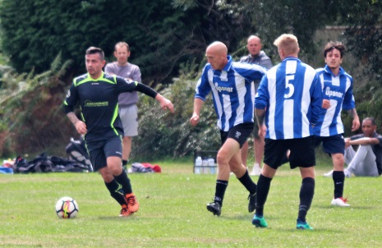
Dan Whitelaw and Callum Goddard both rammed in four when Poole Rovers blitzed Canford Rovers Reserves 10-0 in DIVISION SIX with the other goals coming via Tyler Gregory and an own goal. Kieran Thorne and Joey Garnett netted for Quayside but Longfleet got the better of them 5-2 with goals from Tom Hawksworth, Simon Rose, Elliot Whiting, Jacob Lawrence, and Ben Carr. Callum Miskell (2), Andy Cordial, Michael Buck, and Ian Kay were the Siemans scorers in their 5-1 victory over West Howe Reserves while Kyle Jenkins’ second half strike settled the issue 1-0 for Academy against Boscombe Celtic Reserves.

UNDER 18 DIVISION
The newly formed BHFL UNDER 18 DIVISION got under way with Christchurch winning 3-0 against Bournemouth Poppies thanks to goals from Robbie Webb, Rob Donohoe, and Jacob Miller.
Lymington Town netted through Jason Wallbanke but Hamworthy Recreation had the upper hand 3-1 with goals from Oliver Bird, Johannes Elie, and Joseph Scarano.
Ringwood Town made an impressive start with a 5-0 victory over Redhill Rangers.

